**Mobile Computing – iOS Spring’23**

**Engagement03**

**10 Points**

**Please follow the following instructions to complete this assignment.**

1. Open Xcode from the launchpad of your Mac.
2. Click on create a new Xcode project. Select the iOS template and click on the App application.
3. Click on next which will prompt you to choose options for the project.
4. Provide product name as **LastnameEngagment03**, “**edu.nwmissouri**” for organization identifier, “**Storyboard**” as interface and “**Swift**” as the language.
5. Click on next and select an appropriate location to save your app and click on create. A project directory will be loaded.
6. From the project navigator click on “Main.storyboard” file, a blank mobile screen will be loaded, where the required fields for an app need to be added.

**The View**

Table 1 BMIVC outlets and actions

|  |  |  |
| --- | --- | --- |
| **UI element** | **Purpose** | **Outlet/action name** |
| I UI Label | To display title “BMI Calculator™️” | n/a |
| 1 UITextField | To input age of the user | ageTF |
| 1 UITextField | To input the weight of the user | weightTF |
| 1 UIPickerView | To pick user’s height | heightPicker |
| 1 UILabel | To display the BMI Value | messageLBL |
| 1UIButton | To calculate the BMI of the user | onCalculate: |
| 1UIButton | To reset the app | onReset: |

*Note: Names that are ending with a colon (****:****) are actions.*

1. At first, you will see a single view (first view) in the Main.storyboard file.
2. Create a Cocoa Touch Class “BMIVC” that is a sub class of UIViewController and assign it as class to the first view that is present in the Main.storyboard file. It will be the root view controller of the navigation controller.

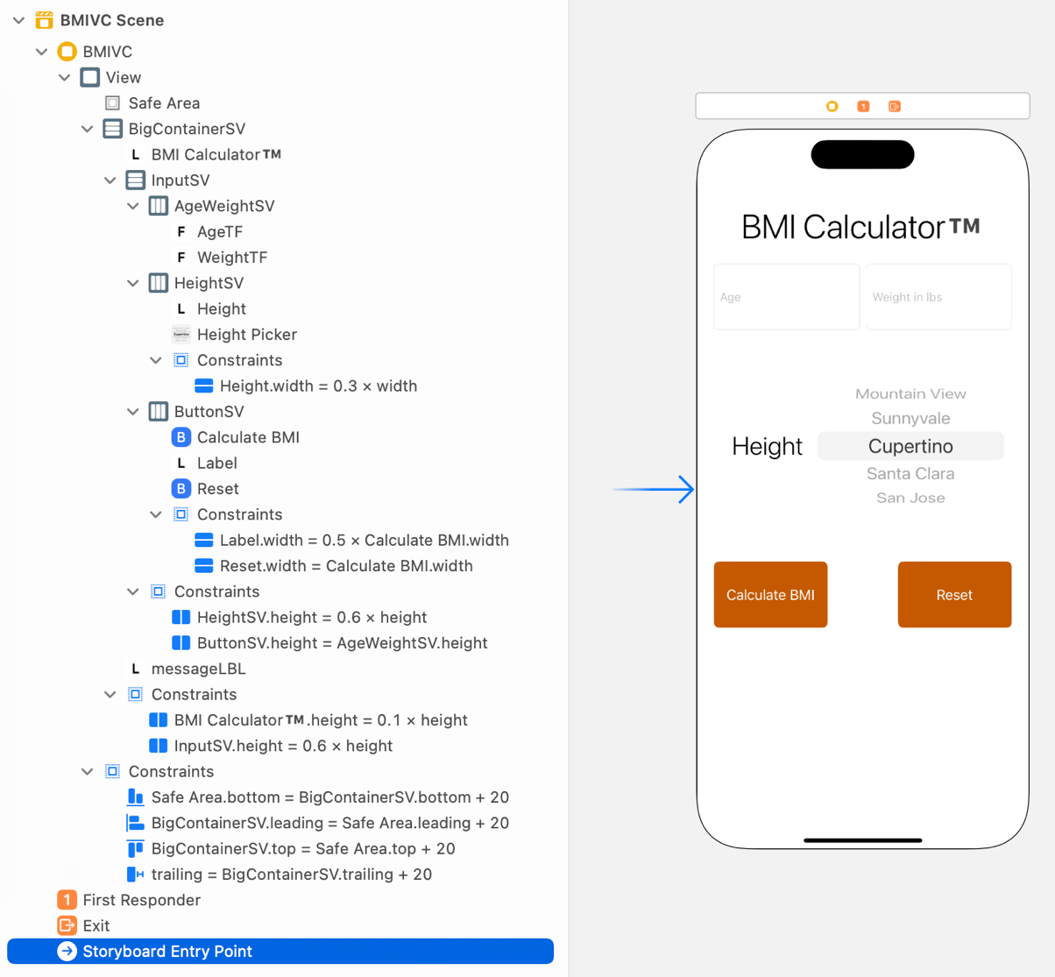

Figure 1 The View

Table 2 BMIVC’s properties for stack views

|  |  |  |  |  |
| --- | --- | --- | --- | --- |
| **Stack View** | **Axis** | **Alignment** | **Distribution** | **Spacing** |
| BigContainerSV | Vertical | Fill | Fill | Standard |
| InputSV | Vertical | Fill | Fill | Standard |
| AgeWeightSV | Horizontal | Fill | Fill Equally | Standard |
| HeightSV, ButtonSV | Horizontal | Fill | Fill | Standard |

**The Controller**

1. ***BMIVC***
   1. Create outlets and actions are per *Table 1***.**
   2. Design the UI as per *Figure 1* and *Table 2*.
   3. When the calculate button is pressed the BMI is calculated and when the reset button is pressed all the values are restored to defaults.
   4. Use a multi component picker view to read user’s height.

**Sample Output (Video Link):**

<https://app.vidgrid.com/view/GHKeDTggg8e0>